With OpenEdge version 10.2B, there is a new way to start and stop the Win202 database – the OpenEdge Explorer, represented on the server desktop as the following shortcut:
Double click the shortcut to open it. Enter the appropriate Username and Password and click OK:
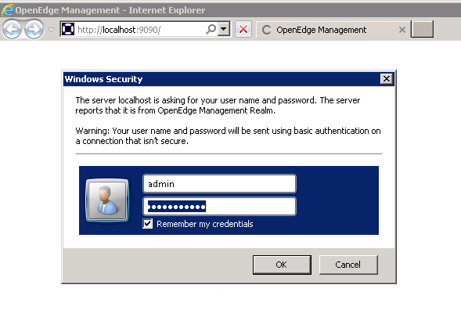
The main screen of the OpenEdge Explorer is then displayed. The circled section below will have the name of your server machine:
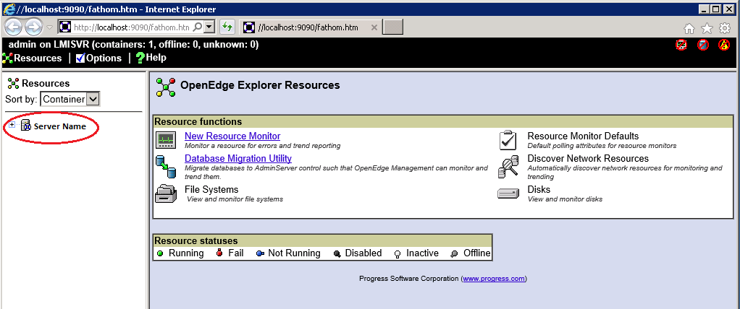
Navigate down from your server name until you see the “win202” database as shown below:
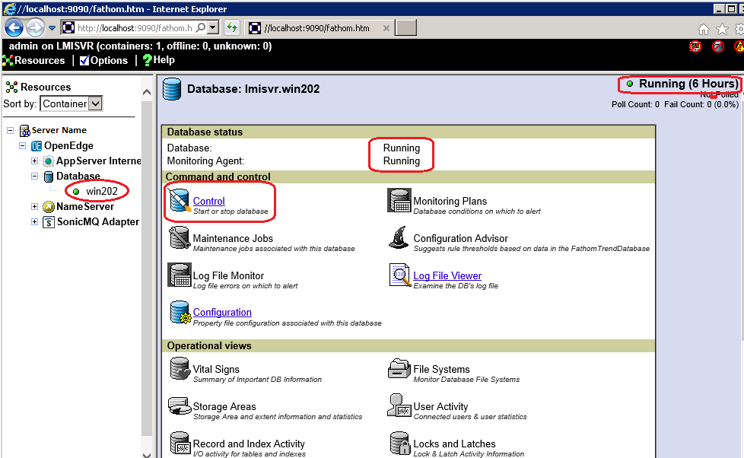
To the right of the database name, the circled parts above show the important pieces of the screen:
- In the Resource tree on the left, the database has a green indicator, indicating that the database is in good standing and it is running.
- In the top right, you can see how long the database has been running.
- The Database status is in the middle.
- The “Control” option is where you will start and stop the database when needed (see below).

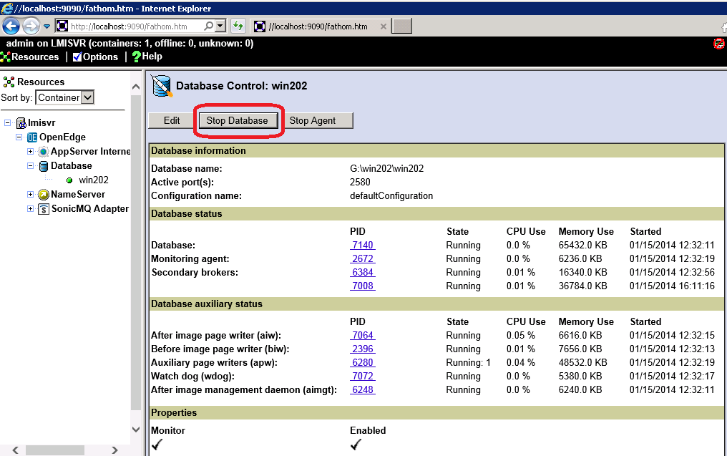

This screen is where you will stop and start the database as you did in the Progress Explorer in prior releases.

When you click the “Stop” button, you will get the message below at which you should click “OK”:
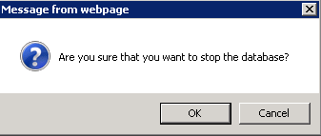

The database will stop and the screen will look like below:
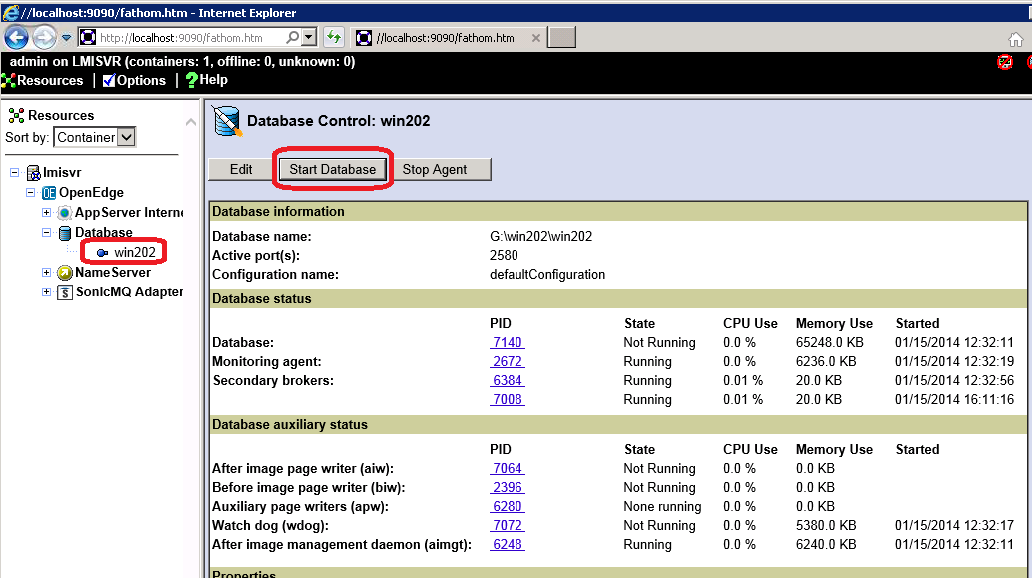
In the Resource tree on the left, the database has a blue indicator, indicating that the database is not started.

To START the database, from this screen click the “Start Database” button.

