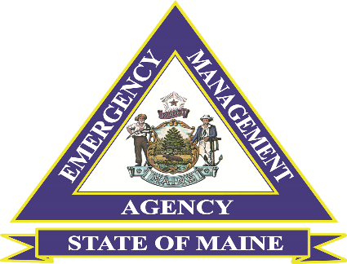
Maine Voluntary Organizations Active in Disaster

ICS 100 and ICS 200 Virtual Courses Announcement

The Maine Emergency Management Agency (MEMA) and the Maine Voluntary Organizations Active in Disasters (MVOAD) are partnering to deliver ICS 100 and ICS 200 Virtual Courses. The target audience for the Courses is VOAD Members, Government, Non-Government, Private and Non-Profit Agencies and Organizations. All Courses will be offered in two parts.

Target Audience: VOAD Members, Government, Non-Government, Private, and Non-Profit Agencies and Organizations.

ICS 100 Introduction to the Incident Command System

This 6-hour 2-part foundation-level course is a virtual interactive course that introduces the Incident Command System (ICS) and provides the foundation for higher-level ICS training. This course describes the history, features and principles, and organizational structure of the ICS. It also explains the relationship between ICS and the National Incident Management System.

ICS 200 Incident Command System for Initial Response

This 6-hour 2-part course is a virtual interactive course that is designed to enable personnel to operate efficiently during an incident or event within the ICS. ICS-200 provides training and resources for personnel who are likely to assume a supervisory position within the Incident Command System (ICS).

Those who register for the course will receive an email confirmation with a Microsoft TEAM’S invitation no less than 48 hours prior to the course session. Course Participants will receive a Certification of Attendance following the delivery of all sessions and the passing of a final examination through the FEMA Independent Study Program portal.

The course will be offered on several dates and times to accommodate the availability of participants at no cost. For further questions, please get in touch with Bill Guindon, MEMA Mass Care Coordinator, at 207-458-2867 or william.guindon@maine.gov
To Register for a Session please fill out the following registration form and select the offering you will attend: (This is a Microsoft Word Fillable Document). Confirmation for course registration will be sent upon receipt.
ICS Course Registration Form
Name:
Agency/Organization Affiliation:
Phone Number: Email:
Course Offerings: (Please check one Part A and Part B sessions you will attend)
ICS 100 (No Prerequisites)
ICS 100 Part A (Select only 1 session per Day)
Date: October 10, 2024, Time: 9:00 a.m. to 12: p.m. Registration Deadline: 10/4
Date: October 10, 2024, Time: 6:00 p.m. to 9:00 p.m. Registration Deadline: 10/4
ICS 100 Part B (Select only 1 per session Day)
Date: October 17, 2024, Time: 9:00 a.m. to 12:00 p.m. Registration Deadline: 10/11
Date: October 17, 2024, Time: 6:00 p.m. to 9:00 p.m. Registration Deadline: 10/11

ICS 200 (Prerequisites ICS 100 or IS 100 C)
ICS 200 Part A (Select only 1 session per Day)
Date: November 7, 2024, Time: 9:00 a.m. to 12:00 p.m. Registration Deadline: 11/1
Date: November 7, 2024, Time: 6:00 p.m. to 9:00 p.m. Registration Deadline: 11/1
ICS 200 Part B (Select only 1 session per Day)
Date: November 14, 2024, Time: 9:00 a.m. to 12:00 p.m. Registration Deadline: 11/8
Date: November 14, 2024, Time: 6:00 p.m. to 9:00 p.m. Registration Deadline: 11/8
Please return completed form to william.guindon@maine.gov

